PAC Dashboard
PAC Dashboard View
Filters
Patient Population – The tool is currently only available for Medicare populations. At this time this option cannot be changed.
Effective Period – Select the period for the patients you want to view, e.g., the active/attributed patients during that period. Effective periods apply to Accountable Care Organizations (ACOs), Primary Care First (PCF), and Direct Contracting Entity (DCE) but not commercial populations as it shows only the most recently imported membership list. Effective Period is intended to display the patients for the time period selected and the current year of data unless the Date range is changed to that of a previous year.
The below definitions are for ACOs:
• QASSGN - A quarterly assignment file supplied from CMS. Note this naming convention was used for Q4 2018 or prior.
• QALR- A quarterly assignment file supplied from CMS. Note this naming convention started in Q1 2019 and after.
• HALR - An annual assignment file supplied from CMS. Note that this naming convention started in 2019 and after.
The below definitions are for DCEs:
• Year M-Month (example is 2021 M12 for December 2021)
The below definitions are for PCFs:
• Q1, Q2, Q3 and Q4
Date Range – Select the date range for the period of time you would like to view data for.

Chart
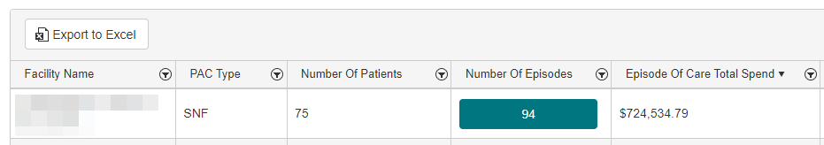

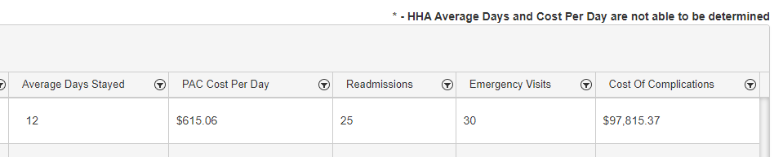
Export to Excel – Use this button to download an .xlsx version of the chart.
Facility Name – The name of the facility that the row of data is showing information for.
PAC Type – The facility type of the PAC events shown for the facility named in the current row of data.
Number Of Patients – The number of individual patients that had this type of PAC event at this facility.
Number Of Episodes – The number of individual PAC episodes of this PAC type in this facility.
Clicking the green button surrounding the Number of Episodes will direct to the Patient View (Below) of the dashboard. Specifying data for the facility and PAC type of the row of data the button is located in.
Episode Of Care Total Spend – The total amount of money spent for the episodes included in this row of data.
*Average Days Stayed – The average number of days stayed for this entry
*PAC Cost Per Day – The cost per day for the PAC Facility and Type shown.
Readmissions – The number of hospital readmissions following PAC episodes that occurred within 60 days of the initial triggering Hospital Admission
Emergency Visits – The number of Emergency Visits following PAC episodes that occurred within 60 days of the initial triggering Hospital Admission.
Cost Of Complications – The cost of complications that occurred within 60 days of the initial Hospital Admissions and following PAC episodes
* - Average Days and Cost Per Day are not calculated for HAA PAC Type at this time.

PAC Patient View
The detail view can be reached by clicking the button in the number of episodes column of the PAC Dashboard View.
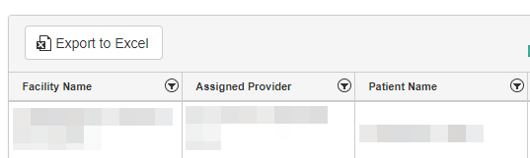
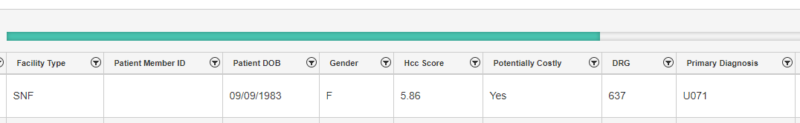
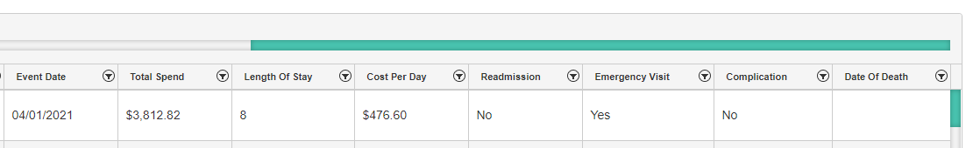
Export to Excel – Use this button to download an .xlsx version of the chart.
Static Columns
The first 3 columns of the PAC Patient View are static and do not scroll with the rest of the chart.
Facility Name – The facility in which the PAC episode took place.
Assigned Provider – The provider the patient shown is assigned to.
Patient Name – The name of the patient who had the PAC Episode.
Additional Columns
Facility Type – The type of facility of the PAC
Patient Member ID – The MBI of the Patient who had this PAC Episode
Patient DOB – The date of birth of the patient
Gender – The gender of the patient
HCC Score – The patient’s HCC score

Potentially Costly – Yes/No is used to indicate if the patient is marked Potentially Costly by Health Endeavors. Potentially Costly Patients are defined as patients with a risk score in top 30% this year or previous year, 1 or more hospitalizations in last 12 months, 3 or more emergency department visits in the last 24 months and 3 or more chronic conditions.
DRG – The DRG the patient was diagnosed with during the initial triggering hospital admission.
Primary Diagnosis – The primary diagnosis given during the PAC episode.
Event Date – The start date of the PAC episode.
Total Spend – The total amount of spend for the PAC episode.
Length of Stay – The length of stay for the PAC episode.
Cost Per Day – The cost per day of the PAC episode.
Readmission – Yes/No is used to indicate whether there was a hospital readmission within 60 days of the initial triggering admission following the PAC episode.
Emergency Visit - Yes/No is used to indicate whether there was an emergency visit within 60 days of the initial triggering admission following the PAC episode.
Complications - Yes/No is used to indicate whether there was a complication within 60 days of the initial triggering admission following the PAC episode.
Date of Death – The date of death of the patient.

